
Green Lane Primary School
Year 4 Spring Term 2 Newsletter 2023

Our Learning next half term
Who were the Anglo-Saxons, Vikings and Normans and how did they change Britain?
How are living things classified?
English:
Through our work on Arthur and the Golden Role this half term, we will be immersing ourselves in a world of ancient storytelling and looking at common features in mythical tales. We will explore important themes of perseverance, determination and the ideas of an ‘unlikely hero’ and use these themes to underpin our writing, which will include a character description, a holiday guide, a diary, a letter and a news report. Our writing will be supported by exploring the story through a variety of teaching approaches
including role on the wall, writing in role, drama and role play.
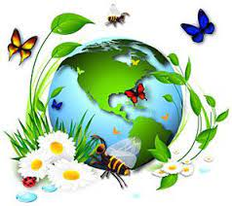

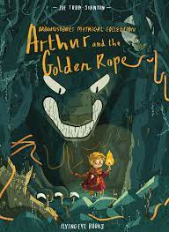

Reading:
We will be exploring a range of texts through a strategy called VIPERS. VIPERS stands for the reading skills: Vocabulary, Inference, Prediction, Explanation, Retrieval and Summarise. These are the key areas which we feel children need to know and understand in order to improve their comprehension of texts.

History
We will be looking at the Anglo Saxons, Vikings and Norman Conquests. Throughout the topic we will use a range of sources and evidence to understand who the Anglo Saxons, Vikings, Norman were. Next, we will discuss and write about the conquests and the waves of invasion. Looking at how they settled and how it has impacted Britain. Thinking about the question, how has the Anglo Saxons, Vikings and Normans impacted the modern world? This will lead onto understanding the role of Williams’ army at the Battle of Hastings in 1066 and the consequences of their victory.
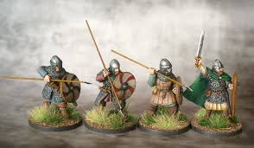

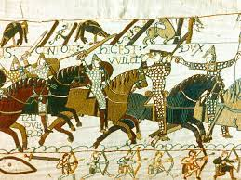

Art
In art, we will explore the work on Henry Moore and evaluate his use of shape and techniques that he has used. Using Moore as inspiration, we will create our own 3D sculptures using clay and paper-mâché. We will reflect on our work by evaluating our pieces and suggesting way in which we could improve our technique.

Science:
Living Things and Their Habitats
During this topic, Year 4 will recognise that living things can be grouped in a variety of ways. We will explore and use classification keys to help group, identify and name a variety of living things in their local and wider environment. As well as recognise that environments can change and that this can sometimes pose dangers to living things.

Project
We want our children to be super creative over the holidays. We’d like all the children in year 4 to have a go at some of these ideas. What could you put on your class display?
- Research – Create and illustrate a mind map all about the Anglo Saxons, Vikings and Norman.
- Picture – Create an illustration of one of your favourite Henry Moore sculpture.
- Writing – Write about animals habitats and how these habitats are suited to them.
- Reading – Find a story about the Anglo Saxons, Vikings and Norman and read it.
- Model – Make your own Henry Moore sculpture using play-doh.
- Drama – Act out being in a Anglo Saxons, Vikings and Norman battle. What happened? Where are you?
- Make – Your own food chain. What does every food chain begin with?
Do anything fun and creative and tell us about it. Post pictures on your class Purple Mash blog or just write about what you have done.
How you can support your child at home
Having conversations with your child is so very important please take the time to talk with them about current news events and anything that is important to your family. It is also essential that you continue to take the time to read with your child and practice times tables with them daily.
Links to websites
www.purplemash.com – Purple Mash
www.activelearnprimary.co.uk & https://go-read.co.uk/ – Bug Club & Go Read
www.ttrockstars.com – TTRS. Get ready for the times tables check
www.mymaths.co.uk – My Maths
www.spellingshed.com – Spelling Shed
www.bbc.co.uk/newsround/news/watch_newsround - News & current affairs for children
www.kids-world-travel-guide.com – Children’s views of different parts of the world
https://www.foodafactoflife.org.uk/7-11-years/ - Information and learning all about food

Key Vocabulary
Practice key vocabulary with your child.
History
- settlement
- hierarchy
- heptarchy
- serfs
- long ships
- mobility
- ruler
- sacking
- seafarer
- successor
- tax
- treaty

Art
- print
- materials
- accurate
- colour
- shape
- form
- design
- abstract
- sculpt
- mouldable
- texture
Science
- backbone
- carnivores
- cold-blooded
- farm
- gills
- herbivore
- omnivore
- pet
- temperature
- vertebrate
- warm-blooded
- wild

February and March have been cold but we’ve done amazing things in class. All your teachers can’t wait to welcome you all back happy, healthy and safe after the break.
All of the Year 4 Teachers

