
Green Lane Primary School
Year 4 Spring Term 2 Newsletter 2023

Our Learning next half term
What allows electricity to moves around a circuit and can we change the movement?
What is a natural disaster and what causes them?

English:
Through our work on Matchbox Diary this half term, we will learn to talk confidently about a picture book and respond to it in a range of ways. We will explore important themes of community, migration, the value of education and legacy and use these themes to underpin our writing which will include a description, a diary, a poem, a persuasive letter and a leaflet. Our writing will be supported by exploring the story through a variety of teaching approaches including role on the wall, writing in role, drama and role play.

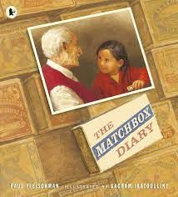

Reading:
We will be exploring a range of texts through a strategy called VIPERS. VIPERS stands for the reading skills: Vocabulary, Inference, Prediction, Explanation, Retrieval and Summarise. These are the key areas which we feel children need to know and understand in order to improve their comprehension of texts.

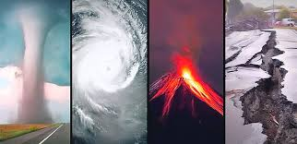
Geography
Natural disasters
We will be looking at where natural disasters occur and looking at them on a map/glove. Year 4 will explore the structure of the Earth, including the types of rocks that appear in the different layers. This will lead onto discovering that the Earth is made up of tectonic plate which is the cause of volcanos, earthquake and tsunamis. We will explore how their constant movement can have dire effects.
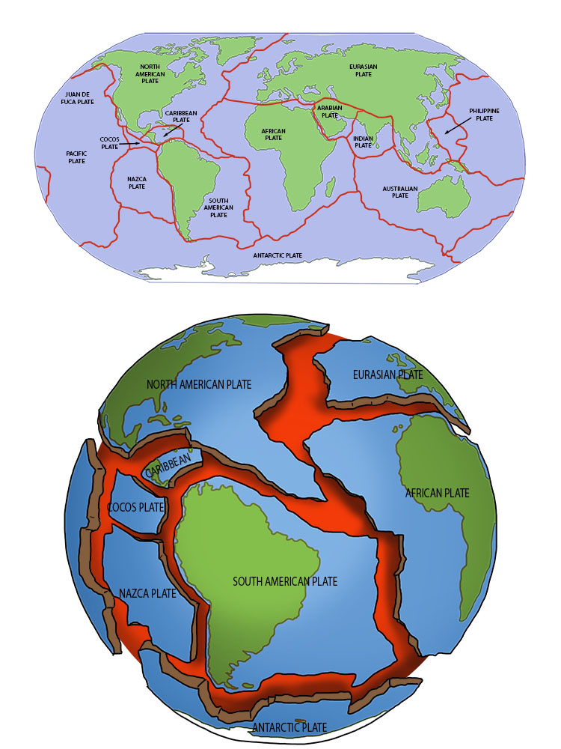

Science:
Electricity
In science, we be learning about types of energy in our world. We will be Identifying and describing how partials moves around a circuit, which is called a current. Year 4 will investigate how this current can move differently through various materials and sort them under the headings conductors and insulators. After we have gained this know, we will make our own circuits using cells, wires, bulbs, buzzers and switches.

DT
In DT we will be creating our own pizza based on another person’s recipe. Next, Year 4 will explore different design and comment on their functionality such as appearance and taste. This will lead onto designing, creating and evaluating our own product.

Project
We want our children to be super creative over the holidays. We’d like all the children in year 4 to have a go at some of these ideas. What could you put on your class display?
- Research – Create and illustrate a mind map all about Amazon facts.
- Picture – Create an illustration of the Amazon Rainforest and turn it into a jigsaw puzzle.
- Writing – Write about what might see as if a volcano explores. Make links to tour book in Spring 1.
- Reading – Find a story with about the Amazon Rainforest or a book about natural disasters and read them.
- Model – Make your own cyclone in a bottle. https://www.mottchildren.org/posts/camp-little-victors/tornado-bottle
- Drama – Act out being in a natural disaster. What happens? Where are you?
- Make – We’ve made landscapes in school. Why don’t you make some at home and tell us about them.
Do anything fun and creative and tell us about it. Post pictures on your class Purple Mash blog or just write about what you have done.
How you can support your child at home
Having conversations with your child is so very important please take the time to talk with them about current news events and anything that is important to your family. It is also essential that you continue to take the time to read with your child and practice times tables with them daily.
Links to websites
www.purplemash.com – Purple Mash
www.activelearnprimary.co.uk & https://go-read.co.uk/ – Bug Club & Go Read
www.ttrockstars.com – TTRS. Get ready for the times tables check
www.mymaths.co.uk – My Maths
www.spellingshed.com – Spelling Shed
www.bbc.co.uk/newsround/news/watch_newsround - News & current affairs for children
www.kids-world-travel-guide.com – Children’s views of different parts of the world
https://www.foodafactoflife.org.uk/7-11-years/ - Information and learning all about food

Key Vocabulary
Practice key vocabulary with your child.
Geography
- Active
- Dormant
- Ash
- Crater
- Earthquake
- Tsunami
- Fault
- Flank
- Mantle
- Vent
- Metamorphic
DT & Art
- Materials
- Design
- Evaluate
- Test
- Assemble
- Tone
- Shade
- Texture
- Technique
- Line
Science
- Energy
- Power
- Insulator
- Conductor
- Particles
- Current
- Circuit
- Voltage
- electrons
- Resistance
- Conductivity

January & February have been cold but we’ve done amazing things in class. All your teachers can’t wait to welcome you all back happy, healthy and safe after the break.
All of the Year 4 Teachers

