
Green Lane Primary School
Year 3 Summer 1 Newsletter 2023

Our Learning next half term
How has the modern world been influence by Ancient Greece?
What is Light?
English:
Through our work on Robot and the Bluebird this half term, we will learn to make emotional responses to a narrative picture book. We will be developing empathy for the characters and setting and forming our own opinions on the situation. We will use these opinions and thoughts to underpin our writing which will include a diary, a non-chronological report, thought bubbles and a narrative. Our writing will be supported by exploring the story through a variety of teaching approaches including role on
the wall, writing in role, drama and role play.
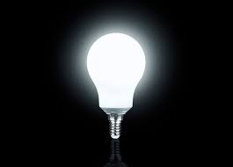

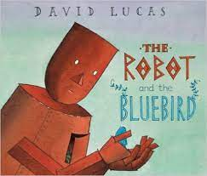

Reading:
We will be exploring a range of texts through a strategy called VIPERS. VIPERS stands for the reading skills: Vocabulary, Inference, Prediction, Explanation, Retrieval and Summarise. These are the key areas which we feel children need to know and understand in order to improve their comprehension of texts.

History
We want to find out about Ancient Greece. First, we will explore how ancient Greece fits into world history. What went before? What went after the ancient Greeks? We will also explore how the ancient Greeks have had a lasting impression on modern society. Looking at how they have influenced education, literature, architecture, language, medicine and science. Did you know that we have used ancient Greek information to make inventions like the water wheel, the alarm clock, the catapult and even, the vending machine!
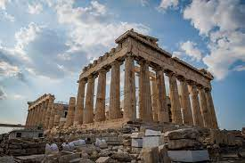

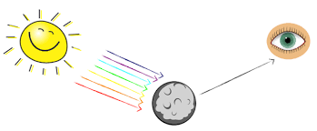

Art
In art, we will be exploring the artist Neil Bousfield to inspire us to create our own printing blocks. We will use these printing blocks to created repeated patterns just like the artist. This will lead onto evaluating mosaics from different civilisations and imitated their techniques to create our own piece of art.

Science:
Light
We will be understanding the world around us by exploring what light is and exploring different sources of light. We will do this by generating questions and testing our ideas using observations and experiments. For example, Does the moon create its own light?
By the end of the unit, we will be able to identifying objects and material that create their own light and those which just simply reflect it.

Project
We want our children to be super creative over the holidays. We’d like all the children in year 3 to have a go at some of these ideas. What could you put on your class display?
- Research – Create and illustrate your own poster about the Ancient Greek.
- Picture – Get inspired by the Ancient Greek and draw your own pot design.
- Writing – Can you explain why the moon is not a source of light?
- Reading – Find a myth from the ancient Greece. Choose your favourite and bring it into schools o we can share it will the class.
- Model – Make your own mosaic using coloured pieces of paper.
- Drama – Act out what the Olympic games were like in ancient Greece. What happens? Where are you?
- Make – Your own Greek food like hummus, pitta or gyros. Why don’t you make some at home and tell us about them!
Do anything fun and creative and tell us about it. Post pictures on your class Purple Mash blog or just write about what you have done.
How you can support your child at home
Having conversations with your child is so very important please take the time to talk with them about current news events and anything that is important to your family. It is also essential that you continue to take the time to read with your child and practice times tables with them daily.
Links to websites
www.purplemash.com – Purple Mash
www.activelearnprimary.co.uk & https://go-read.co.uk/ – Bug Club & Go Read
www.ttrockstars.com – Time Table Rockstars
www.mymaths.co.uk – My Maths
www.spellingshed.com – Spelling Shed
www.bbc.co.uk/newsround/news/watch_newsround - News & current affairs for children
www.kids-world-travel-guide.com – Children’s views of different parts of the world
https://www.foodafactoflife.org.uk/7-11-years/ - Information and learning all about food

Key Vocabulary
Practice key vocabulary with your child.
History
- CE & BCE
- artefact
- century
- chariot
- leisure
- modern
- mythology
- myths
- democracy
- source
- trade
Art
- print
- blocks
- colour print
- repetitive
- cut
- overlap
- materials
- experience
- mosaic
- design
- evaluate
Science
- light source
- dark
- absence of light
- surface
- shadow
- reflect
- energy
- opaque
- transparent
- translucent
- travels
February and March have been cold but we’ve done amazing things in class. All your teachers can’t wait to welcome you all back happy, healthy and safe after the break.
Miss Deciacco, Miss Bhalla, Ms Fazal & Miss Akmal

