
Green Lane Primary School
Year 3 Spring Term 2 Newsletter 2023

Our Learning next half term
What are functions of a flowering plants and what impact do they have on our environment?
Where is the Amazon river and is like Bradford Beck?
English:
Through our work on Pattan’s Pumpkin this half term, we will learn to talk confidently about a picture book and respond to it in a range of ways. We will explore important themes of community, perseverance and determination and use these themes to underpin our writing which will include a set instructions, a diary, a letter of advice and a leaflet. Our writing will be supported by exploring the story through a variety of teaching approaches including role on the wall, writing in role, drama and role play.
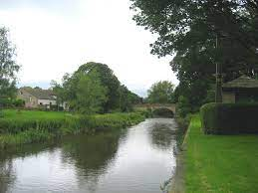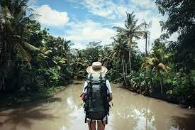

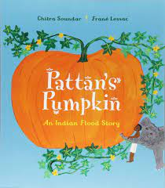

Reading:
We will be exploring a range of texts through a strategy called VIPERS. VIPERS stands for the reading skills: Vocabulary, Inference, Prediction, Explanation, Retrieval and Summarise. These are the key areas which we feel children need to know and understand in order to improve their comprehension of texts.

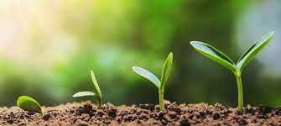
Geography
We want to find out about the Amazon and the Amazon river. Our learning will include Identifying the tropics and longitude and latitude of the Earth on a map/globe, explore the importance of the Amazon rainforest & investigate the impact of deforestation is have on the Earth. In class, we will understand the importance of rivers on human activity along the Amazon river and finding out fascinating facts that will blow your mind!
This half-term we have our Ingleborough cave visit as well.
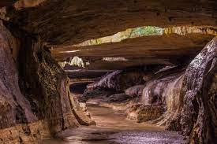

DT & Art
In DT we will be creating our own mini greenhouses based on another other designs we gather. Next, Year 3 will explore different design and comment on their functionality. This will lead onto designing, creating and evaluating our own product.

Science:
Plants
We will be Identifying and describing the functions of different parts of flowering plants. We will also explore the requirements of plants for life and growth and how they vary from plant to plant.
Investigate the way in which water is transported within plants. The children will explore the role of flowers in the life cycle of flowering plants, including pollination, seed formation and seed dispersal.

Project
We want our children to be super creative over the holidays. We’d like all the children in year 3 to have a go at some of these ideas. What could you put on your class display?
- Research – Create and illustrate a mind map all about plant facts.
- Picture – Create a river picture and turn it into a jigsaw puzzle.
- Writing – Write about what might see as you float down a river in the Amazon.
- Reading – Find a story with a river in it or a book about plants and read them.
- Model – Make a model of a plant.
- Drama – Act out a journey down a river in the Amazon. What happens? Where are you?
- Make – We’ve made secondary colours in school. Why don’t you make some at home and tell us about them!
Do anything fun and creative and tell us about it. Post pictures on your class Purple Mash blog or just write about what you have done.
How you can support your child at home
Having conversations with your child is so very important please take the time to talk with them about current news events and anything that is important to your family. It is also essential that you continue to take the time to read with your child and practice times tables with them daily.
Links to websites
www.purplemash.com – Purple Mash
www.activelearnprimary.co.uk & https://go-read.co.uk/ – Bug Club & Go Read
www.ttrockstars.com – Time Table Rockstars
www.mymaths.co.uk – My Maths
www.spellingshed.com – Spelling Shed
www.bbc.co.uk/newsround/news/watch_newsround - News & current affairs for children
www.kids-world-travel-guide.com – Children’s views of different parts of the world
https://www.foodafactoflife.org.uk/7-11-years/ - Information and learning all about food

Key Vocabulary
Practice key vocabulary with your child.
Geography
- River
- Source
- Flood
- Bend
- Tributary
- Climate change
- Deforestation
- Tropics
- Forest floor
- Middle layer
- Canopy
DT & Art
- Materials
- Design
- Evaluate
- Test
- Assemble
- Tone
- Shade
- Texture
- Technique
- Line
Science
- Root
- Stem
- Flower
- Leaf
- Seed
- Life Cycle
- Transpiration
- Photosynthesis
- Nutrients
- Growth

January & February have been cold but we’ve done amazing things in class. All your teachers can’t wait to welcome you all back happy, healthy and safe after the break.
Miss Deciacco, Ms Bhalla, Ms Fazal & Miss Akmal

